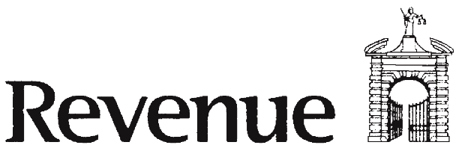CHY 4 Cert

ANNUAL TAX CERTIFICATE

SECTION 848A TAXES CONSOLIDATION ACT (TCA) 1997
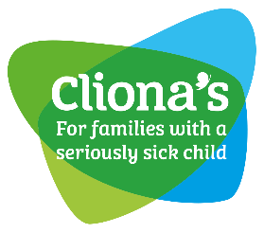

TAX RELIEF FOR DONATIONS TO ELIGIBLE CHARITIES AND OTHER APPROVED BODIES

This form should be completed by donors who are individuals in respect of donations made on or after 1 January 2013. (Both self-assessed and PAYE taxpayers.)
  - You should not complete Form CHY 3 (Enduring Certificate) for a tax year if you have completed, or intend to complete, a Form CHY 4 for the same year.
NOTES: Please refer to the notes at www.revenue.ie/en/tax/it/forms/chy4cert-charity.pdf (or contact us for a copy) before completing this form.

(COMPLETE IN BLOCK CAPITALS PLEASE)
PART A
Name of Donor: PPS Number:

Charity Ref. No.:

18127

Don’t know your PPS No.? See your pay slip, social services card or check recent correspondence from Revenue.

Address: Phone No:

Email Address:

PART B
Name of eligible charity or other approved body (hereinafter referred to as an approved body):

PART C

I certify that for the tax year -

€

- I have made a donation of to the approved body referred to in Part B (for tax relief purposes, donations to an approved body must amount to at least €250 in a tax year),
- The donation was made in money and/or designated securities,
- I was resident in the State for that tax year,
- I have paid or will pay Income Tax/Capital Gains Tax of an amount equal to Income Tax on the grossed up amount of my donation,
- Neither I nor any person connected with me have received or will receive a benefit from the approved body in consequence of having made this donation, and
- The donation was not subject to a condition as to repayment nor conditional on, or associated with, the acquisition of property by the approved body other than by way of gift, from me or a person connected with me.

I am aware that-
- The approved body referred to in Part B may use my PPS Number for the purpose of a claim for tax relief under section 848A TCA 1997 on foot of this annual certificate or a renewed annual certificate,
- The aggregate amount of my donations to an approved body or bodies in a tax year cannot, for tax relief purposes, exceed €1,000,000,
- The amount of my aggregate annual donations in a tax year to an approved body or bodies with which I am associated are, for tax relief purposes, restricted to an amount equal to 10% of my total income of that year (see notes), and
- I must advise the approved body immediately of any change in my circumstances that would affect the body’s entitlement to claim tax relief in respect of my donations.

Please tick ✓the box if you are associated with the approved body named in this certificate. (see notes)
Signature: Date:

(DDMMYY)

Thank you for taking the time to fill in this form. Please return it to us in the pre-paid envelope provided.

